**Installing MySQL Server**

1. Open a terminal window and run the command:  
   sudo apt update
2. Then:  
   sudo apt install mysql-server
3. Start the service:  
   sudo systemctl start mysql.service
4. Get into the MySQL shell  
   sudo mysql
5. (Optional) Add a password for the root user:

ALTER USER 'root'@'localhost' IDENTIFIED WITH mysql_native_password BY 'root';

Note: the above statement will add a password of *root* to the user, so the user is root and the password is root.

1. Exit the MySQL with:

exit

1. Log back into the shell using the new password:

mysql -u root -p

Note: after typing in this line, the computer will wait for you to enter the password. You will not see the password but once you are done, you will see the MySQL prompt

1. Create a new user with:

CREATE USER 'axle'@'host' IDENTIFIED BYauthentication_plugin BY 'axle12345';

1. Then make the user an admin:

GRANT ALL PRIVILEGES ON *.* TO 'axle'@'localhost';

**Installing MySQL Workbench using Snap**

1. Open a terminal window and run the command:  
   sudo snap install mysql-workbench-community
2. Then check the applications area of Linux:  
   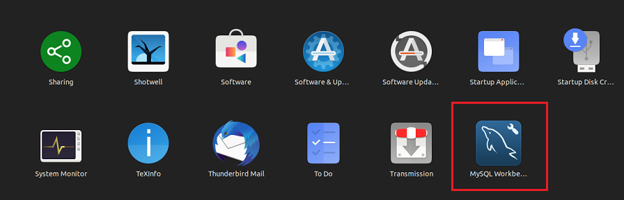
3. Right click on the Local instance and choose edit  
   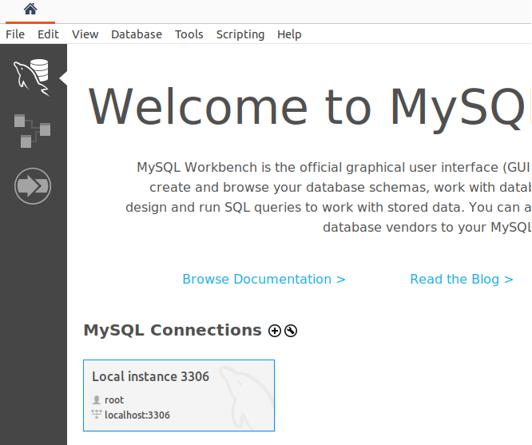
4. On the Manage Server Connections window, change the name to the user you created in a previous step #8 above; you will need the user’s password:  
   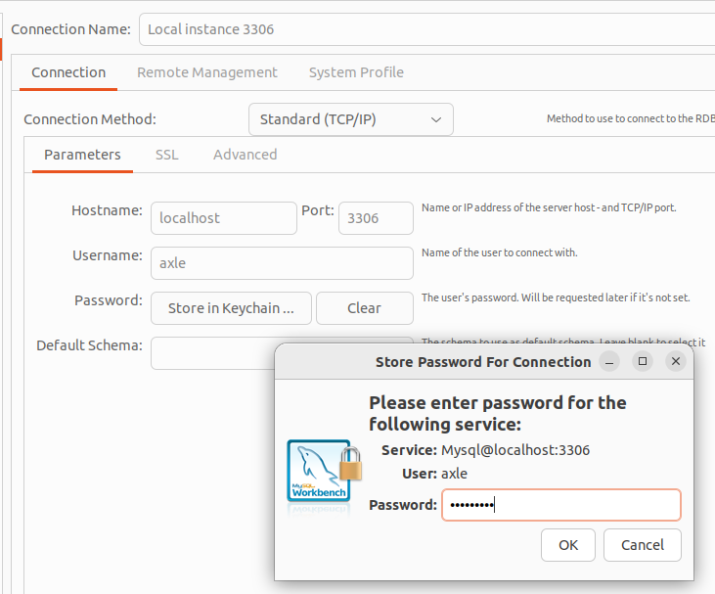
5. Test the connection
6. If successful, the local instance should now have the user’s name:

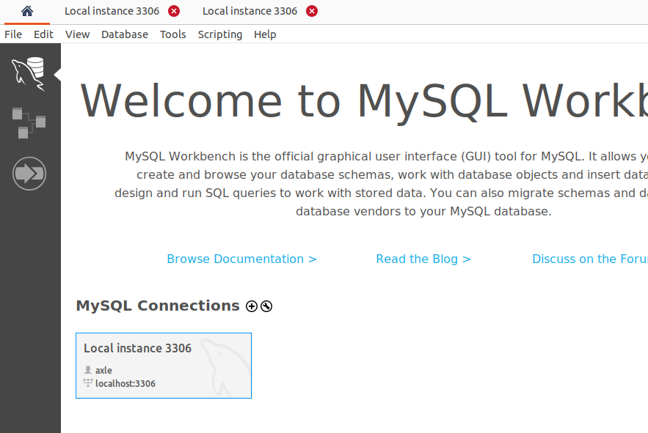

1. Click on the instance to begin interacting with MySQL